Link: https://onlinelibrary.wiley.com/doi/10.1002/jpn3.70073


ORIGINAL ARTICLE

Sirolimus utilization in pediatric liver transplantation: A large high-volume quaternary center experience
Wenly Ruan, Dana N. Cerminara, Nhu Thao Nguyen Galvan, Douglas S. Fishman, Sanjiv Harpavat, Paula M. Hertel, Krupa R. Mysore, Mary Elizabeth Tessier, Kelby Fuller … See all authors
First published: 19 May 2025

https://doi.org/10.1002/jpn3.70073
Read the full text

Abstract

Objectives
Optimization of liver transplant (LT) immunosuppression is essential for long-term graft function in children. Mammalian target of rapamycin (mTOR) inhibitors, such as sirolimus, have not been extensively studied in pediatric LT. We aimed to explore the usage of and indications for sirolimus at a quaternary pediatric LT center in a retrospective cohort analysis.

Methods
Pediatric LT patients who received sirolimus from 2010 to 2018 were included. Their electronic medical records were evaluated for demographic information, clinical data, and laboratory data before and after initiation of sirolimus.

Results
Sirolimus was initiated on 41 pediatric LT recipients at a median of 0.67 years post-transplant (interquartile range [IQR]: 0.13–1.83) at Texas Children's Hospital. The leading indications for initiating sirolimus were chronic rejection (CR) (n = 12, 29.3%), T-cell-mediated rejection (TCMR) on tacrolimus (n = 8, 19.5%), posterior reversible encephalopathy syndrome (PRES) (n = 8, 19.5%), and unresectable hepatic tumors/malignancies (n = 7, 17.1%). Among patients started on sirolimus for CR, 58% (n = 7/12) demonstrated histological or biochemical improvement. Among those started for TCMR augmentation, 62.5% experienced biochemical improvement. No patients who started on sirolimus for unresectable hepatic tumors/malignancies had malignancy recurrence 1-year post-LT. Median cholesterol and triglyceride levels 1-year post-initiation were higher than values 1-year pre-initiation (p < 0.0001); however, sirolimus-induced anemia, nephrotoxicity, and HAT were not observed.

Conclusions
This study is among the first to review the clinical experience of sirolimus usage in pediatric LT. Our experience suggests sirolimus can be used safely and effectively. Further research is warranted to evaluate long-term benefits, adverse effects, and optimal dosing of sirolimus in pediatric liver transplantation.

Graphical Abstract
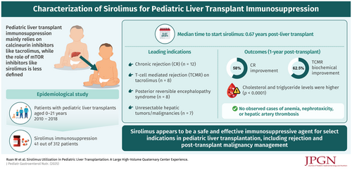

CONFLICT OF INTEREST STATEMENT
The authors declare no conflicts of interest.

