Link: https://onlinelibrary.wiley.com/doi/10.1002/jpn3.70122


ORIGINAL ARTICLE

Accuracy and outcomes of endoscopic ultrasound guided anal botulinum toxin injections for pediatric constipation: A pilot study
Brianne Shuler, Alexandra L. Kilgore, Paul Tran, Taylor Montminy, Lori Silveira, Jaime Belkind-Gerson, Jacob A. Mark
First published: 18 June 2025

https://doi.org/10.1002/jpn3.70122
Jaime Belkind-Gerson and Jacob A. Mark are senior authors that worked equally in this study.
Read the full text

Abstract

Objectives
Injection of Onabotulinumtoxina (BT) into the internal anal sphincter (IAS) is commonly used for pediatric constipation. Typically, BT injections are guided by anatomic landmarks (standard technique [ST]). This pilot study assessed the accuracy of BT injection placement with ST versus endoscopic ultrasound (EUS) guidance and compared clinical outcomes.

Methods
Children aged 2–18 with chronic functional constipation undergoing BT injections without anorectal anatomic or neurologic abnormalities were eligible. Fifteen children were enrolled in the intervention arm with ST placement and needle location assessment using EUS. Subsequently, EUS-guided injection was specifically placed into the IAS. Additionally, 30 children (controls) received BT by ST without EUS-guidance. A constipation severity questionnaire was administered at 2 weeks, 3 months, and 6 months postprocedure.

Results
The initial needle tip location was the IAS for 30 placements (50.1%, 95% confidence interval [CI]: 38.1%–63.5%) and the external anal sphincter in 15 placements (20.3%, 95% CI: 11.8%–32.8%) of a total 59 injections assessed by EUS. Patients reported improvement at 2 weeks, 3 months, and 6 months in both study groups. Constipation scores obtained only after injections were worse in EUS versus control (22.21 vs. 13.83, p < 0.0001) at 2 weeks, with no significant difference at 3 (15.8 vs. 13.57, p = 0.127) or 6 months (13.10 vs. 13.27, p = 0.9322).

Conclusions
This study shows the IAS is injected with BT only 50% of the time with standard technique based on anatomical landmarks.

Graphical Abstract
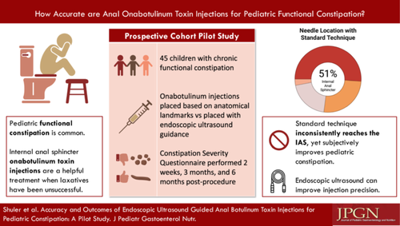

CONFLICT OF INTEREST STATEMENT
The authors declare no conflicts of interest.

