Link: https://onlinelibrary.wiley.com/doi/10.1002/jpn3.70041


ORIGINAL ARTICLE

Clinical outcomes of maintenance therapy with sulfasalazine compared to 5-aminosalicylates in children with ulcerative colitis
Ishrat Mansuri, Sophia Wang, Laurie Fishman, Paul A. Rufo, Enju Liu, Christina Chan, Athos Bousvaros
First published: 10 April 2025

https://doi.org/10.1002/jpn3.70041
Read the full text

Abstract

Objectives
Sulfasalazine (SZ) and 5-aminosalicylates (5-ASA) have been widely used treatments for ulcerative colitis (UC). Although some studies suggest SZ may be superior, limited data exists comparing the two in children. This study aimed to describe real-world data on their comparative safety and efficacy in children and the impact of switching between SZ and 5-ASA before treatment escalation.

Methods
We retrospectively reviewed the electronic medical records of children diagnosed with UC between June 1999 and December 2019 at Boston Children's Hospital. We described outcomes at 1 year and long-term in patients treated with SZ or 5-ASA as a first-line maintenance agent.

Results
Among 433 patients (age 0–19 years), 124 started on SZ and 309 on 5-ASA. Forty-eight patients switched between the two drugs within the first year, and 74 switched during long-term follow-up. The main reason for switching from SZ to 5-ASA was adverse reactions. At 1 year, 54%, 44.3%, and 36.6% of patients on SZ, 5-ASA, and those who switched, respectively, were in steroid-free remission (p = 0.13). Patients who switched due to lack of efficacy or adverse reactions were four times more likely to escalate treatment compared to nonmedical reasons. Patients with Pediatric Ulcerative Colitis Activity Index >65 at the diagnosis are more likely to require treatment escalation (p = 0.0043).

Conclusions
SZ and 5-ASA are effective first-line treatments for mild to moderate pediatric UC. SZ tends to have more minor adverse reactions. Switching between SZ and 5-ASA does not offer therapeutic benefits, and disease severity at diagnosis predicts early treatment escalation.

Graphical Abstract
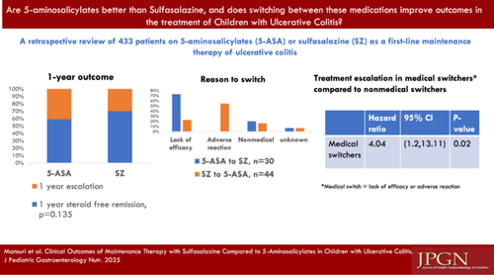

CONFLICT OF INTEREST STATEMENT
The authors declare no conflicts of interest.

